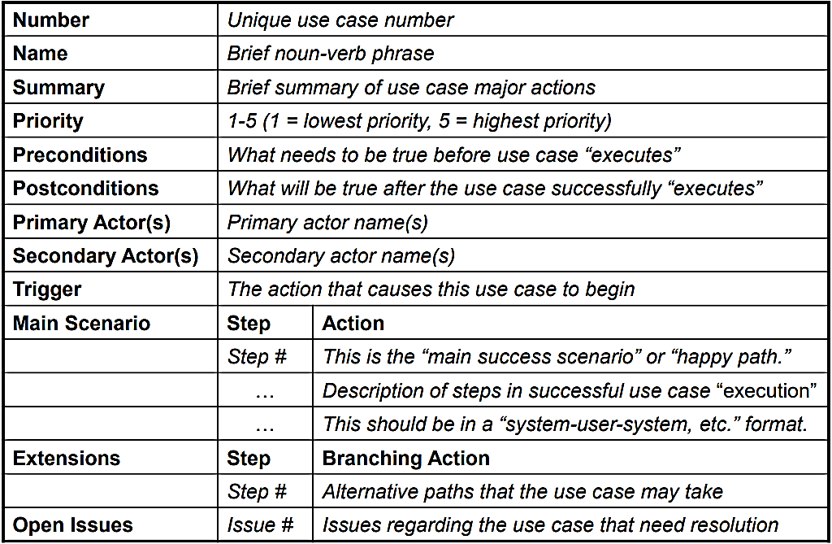
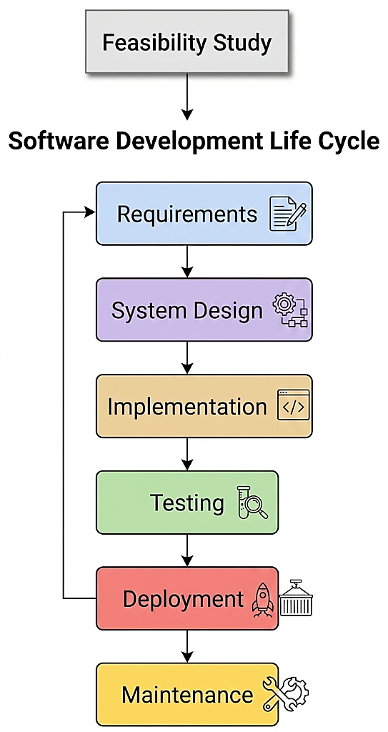
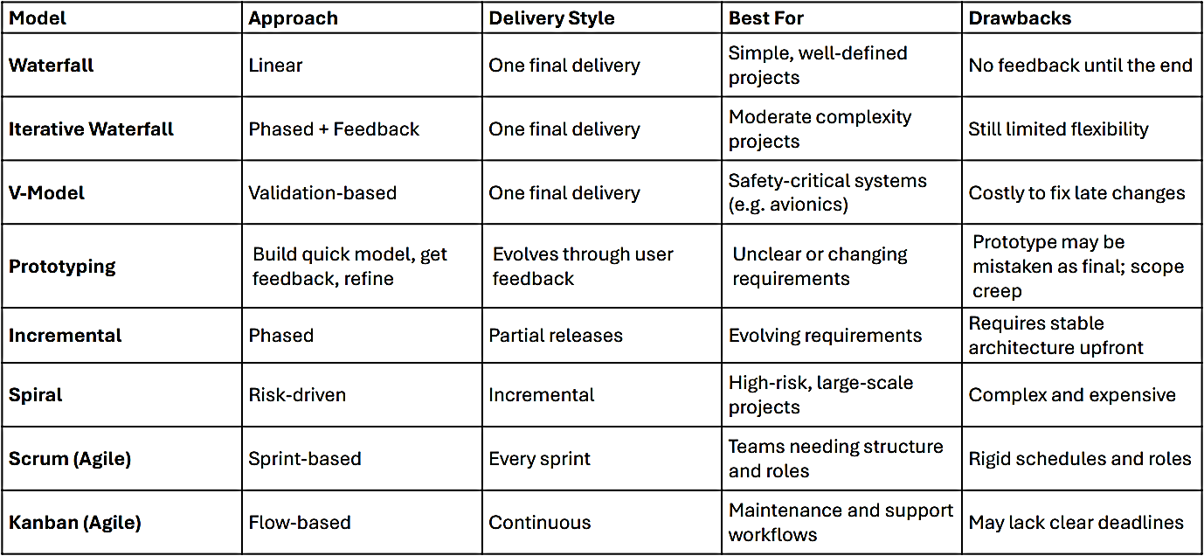
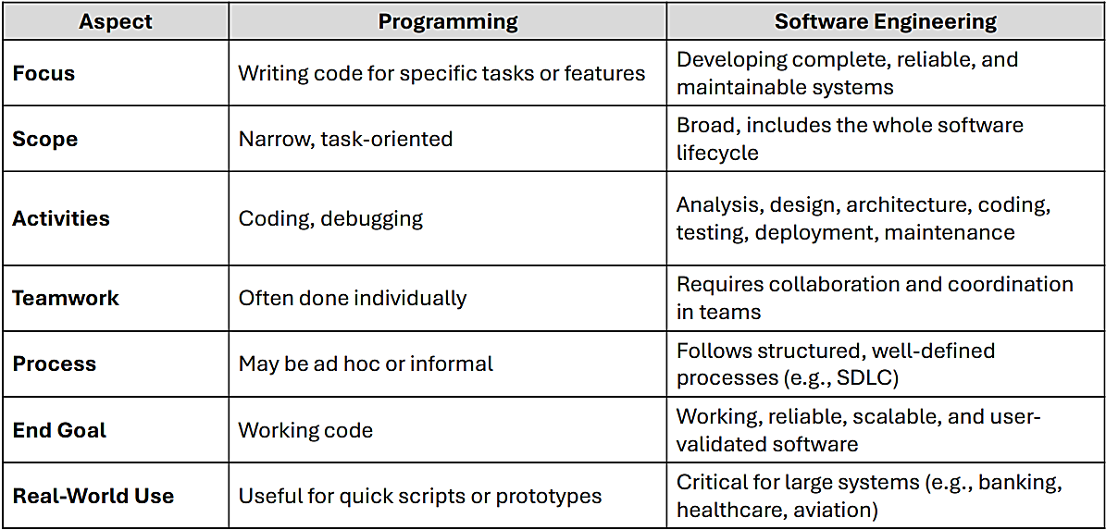
SE: Applying engineering principles to build software that is reliable, efficient & easy to maintain; Follows structured processes; Ensuring quality at every step; Planning across the entire software lifecycle; Saves time & money in the long run; Protects users & ensures their satisfaction; Avoids major failures; Software Crisis (1960s – 1990s): Many software projects were failed due to over budget, missed deadlines, system crashes & disasters; Therac-25: Patients received massive radiation overdoses (poor testing, missing safety checks); Ariane 5 Rocket: Exploded 40s after launch (reused code w/o proper adaptation); Mariner 1 (NASA): Veered off course & self-destructed (a missing hyphen in code!); Knight Capital: Lost $440 million in 30 mins (wrong code update in stock trading bot); SDLC: A step-by-step process used to develop software; Helps team meet user needs & expectations; Saves time & cost by planning ahead; Avoids risks & delivery delays; Feasibility Study: Used by managers/stakeholders to approve/reject the project; Technical Feasibility: Do we have the required hardware, software & skills? Economic Feasibility: Will the benefits outweigh the expenses? Legal Feasibility: Are there any laws, policies / regulations to follow? Operational Feasibility: Will the system work in the real world? Will users use it? Schedule Feasibility: Can we deliver it on time? Requirement Gathering & Analysis: Write it down clearly in a Software Requirements Specification (SRS) of what the user wants the system to do; Involved people: Clients; Users; Business analysts; Techniques for gathering requirements: Interviews (w. users; for deep evidence); Questionnaires (for broad standardized input); Observations (watching their daily works to find pain points, inefficiencies/system improvement needs); Document analysis (current reports, forms/system manuals to understand existing workflows & rules); Group discussions (workshops/focus groups; resolves conflicts & builds shared agreement); Showing examples (prototyping – create mockups/sample screens to help users visualize the system & give early feedback); Generating ideas (brainstorming); Functional Requirements: Describe what the system should do; Non-Functional Requirements: Describe how well the system should perform (e.g.: accessible on both desktop & mobile devices); Limitations (Constraints): Rules/boundaries the system must follow (e.g.: deployed within the university’s local network only); Best practices: Involve all key stakeholders early in the process; Use clear, simple language (avoid technical jargon); Validate requirements w. stakeholders using reviews / walkthroughs (a peer review meeting where the team goes through the software requirements, design, or code step by step to check for issues); Clearly document any assumptions & limitations; Maintain traceability to track requirements through design, development & testing; Common mistakes: Guessing stakeholder needs (assuming what users want w/o asking/confirming); Using too much technical jargon (writing requirements that non-technical users can’t understand); Not documenting assumptions/limitations; Ignoring non-functional requirements; Failing to update requirements & changes; Stakeholder: Any person or group who has an interest in the software system (uses/manages the system); End Users: Directly uses the system; Internal Users: Staff within organization who support/manage the system; External Partners: 3rd parties that the system interacts w. (payment gateways, suppliers); Regulatory Bodies: Authorities that set rules/standards the system must follow; Project Sponsor/Client: Funding/owning the system; Requirement Validation: Checks correctness w. stakeholders; Traceability: Maintains links through later lifecycle works; Requirement Traceability: Requirement through design, development & testing, helping the team verify that it’s implemented & tested; System Design: SRS (Software Requirements Specification) → System blueprint; Break down what the system should do → Design components; What’s Included: UI Design; Database Schema; System Architecture (front-end, back-end, APIs together); Output: High-level design (overall structure); Low-level design (detailed logic & components); Implementation (coding): Developers write actual code based on design documents; Follow coding standards, use the right tools & technologies; Built module by module; Each module is tested individually (unit testing); Testing: Tests both individual parts (modules) & the entire system; Goal is to find & fix bugs; Makes sure the software works as expected based on the requirements; Types: Unit Testing (function/module); Integration Testing (Makes sure separately developed modules work well together); System Testing (whole system); Acceptance Testing (Check if system meets client’s requirements); Deployment: Finished software is installed in the real environment where users will use it; May include a pilot release (testing with a small group first); Users are trained & user manuals / help documents are prepared; Help desks, technical support/FAQs are provided to assist users during the transition; Maintenance: Bug fixes, feature updates & system improvements; The goal is to keep the system functional, useful, problem-free, secure & up to date; Why It Matters: New user needs; Technology updates; Security risks; Types: Corrective Maintenance: Fixes bugs/errors found after system is deployed; Adaptive Maintenance: Changes software to work in a new environment; Perfective Maintenance: Improves system by adding new features/enhancing performance; Ethics: Set of moral values that help us decide what is right/wrong in our actions; Being responsible, fair & professional in everything we do; It guides professionals throughout the entire SDLC; Key Ethical Values: Responsibility (take ownership of your work and its impact; public safety; proper escalation); Transparency (be honest about how the software works); Privacy (protect users’ personal information); Fairness (avoid discrimination/bias in your system); IEEE Code of Ethics: Global body for engineering, computing & electronics; Publishes technical standards; Focus: Hardware, electrical & computer engineering; Last Updated 2020 (minor revision); ACM (Association for Computing Machinery) Code of Ethics & Professional Conduct: World’s largest society for computing professionals; Focus: Computer science, education, software research; Offers journals, conferences & certifications; Last updated in 2018; IEEE/ACM Code of Ethics: A joint code created in 1999 specifically for Software Engineers; Known as the Software Engineering Code of Ethics & Professional Practice; Includes 8 core principles (public, client, product, judgment, management, profession, colleagues, self); BCS Code of Conduct (UK): Focus on public interest, professional competence & accountability; Australian Computer Society (ACS) Code of Ethics: Includes privacy, respect, social impact; IFIP (International Federation for Information Processing) Code of Ethics: Promotes ethical computing globally;
Software Process Model: Structured method/strategy that guides how the SDLC phases are carried out; Provides framework/roadmap for organizing & managing tasks in SDLC;
SDLC | Software Process Models
Defines what phases to follow | Defines how to execute those phases
General structure | Specific implementation
Same phases used across models | Each model organizes, iterates, or emphasizes phases differently
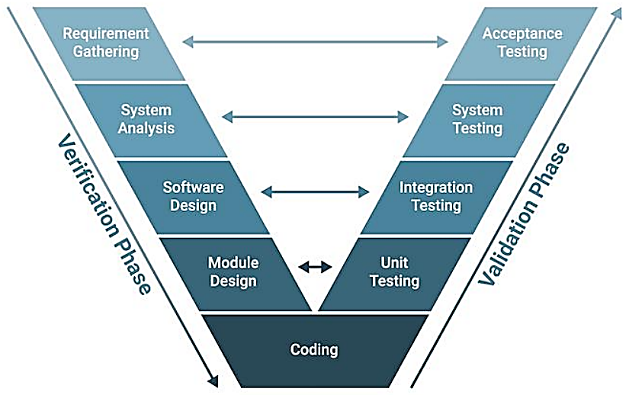
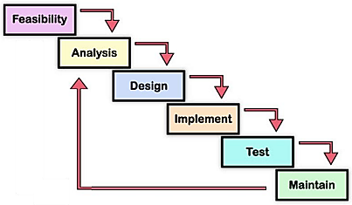
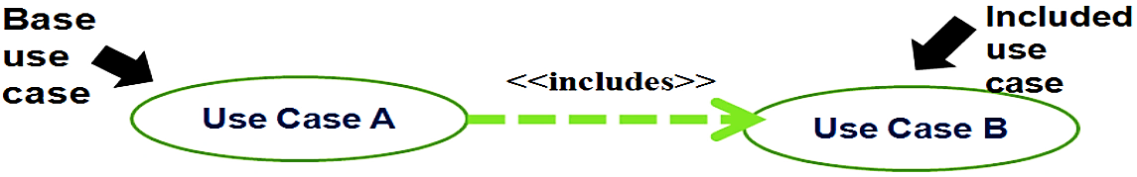
¹Waterfall Model: Linear; Step-by-step process; Each phase is completed before moving to the next; Simple & easy to understand; Each phase has clear goals & deliverables; Not suitable for projects where requirements may change later; One-time delivery Best use case: Project requirements are clearly known in advance & unlikely to change; ²Iterative Waterfall Model: Modified version of traditional Waterfall Model; Allows feedback & revisions between phases; Follows same step-by-step phases as classic Waterfall, but teams can go back to earlier phases if needed; Reduces rigid structure of original Waterfall model; Allows for corrections & improvements before final product is delivered; Benefit: More flexible & realistic for real-world projects where issues may only appear in later stages; When to use: Requirements are mostly clear, but some minor changes may be needed during development; Client feedback is available @ the end of each phase; Medium-sized system w. moderate risk (not too complex, but not too simple either); ³V Model (Verification & Validation): Variation of waterfall; Focuses on testing @ every stage of development; Left → Planning & designing; For every development step, there is a corresponding test step; Why use it: This model helps catch errors early by planning tests as soon as each phase begins; Common use: Ideal for safety-critical systems (Medical devices, Automotive systems); ⁴Prototyping Model: Initially build a quick & rough version of the system (a prototype) to show users early; They test it & give feedback, so we can improve the design before building the final system; Throwaway Prototyping: Temporary prototype built for learning & then discarded; Evolutionary Prototyping: Progressively refines the prototype into operational system; How it works: Gather basic requirements → Build a quick prototype → Show it to the user → Get feedback & improve it → Once users are happy → Build the real system; Why use it: Helps understand what user really wants; Saves time by avoiding big mistakes; Great for projects where requirements are unclear/may change; ⁵Incremental Model: System is developed step-by-step in small parts called increments; Built & delivered in smaller functional units, not all at once; Each increment adds new features to the system; Every increment goes through the entire SDLC; User feedback from earlier increments can help improve future ones; Why use it: It allows early delivery of useful features & supports ongoing improvements; When to use: Working on very large projects; Most requirements are known, but full system needs to be developed in phases; Quick delivery of working features & early user feedback; To spread out the risk across multiple stages of development; Version based increments; ⁶Spiral Model: Risk-focused & iterative; Waterfall + Prototyping; Each loop → Phase of the project; Project moves through these loops repeatedly, improving the product each time; Structure: Planning: Set goals, define system requirements; Identify constraints & possible solutions; Risk Analysis: Identify potential risks (cost, time); Analyze & take steps to reduce/eliminate those risks; Engineering: Design, build & test part of the system (a prototype/increment); Evaluation: Customer reviews the work done; Based on feedback, next loop (iteration) is planned; When to use: Large, complex / high-risk project; Requirements aren’t fully known @ beginning & may change over time; Project needs frequent reviews, testing & updates; Want to identify & reduce risks early: Mistakes can be very costly/dangerous (defense/aerospace systems); ⁷Agile Model: Iterative & incremental; Built & delivered in small usable parts called sprints (usually 1–4 weeks); Each sprint delivers a working product; Encourages continuous improvement & quick responses to change; Based on the Agile Manifesto (2001) – values people & interactions over rigid processes; Focuses on: Team collaboration; Customer involvement & feedback; Flexibility to change; E.g.: Mobile Applications; Cloud-based SaaS Products; Best for: Projects where requirements may change frequently & fast delivery is important; Agile Frameworks: It is a philosophy based on a set of values & principles (from Agile Manifesto); Scrum: Focuses on working in short, fixed-length cycles called sprints (usually 2–4 weeks); Key Roles: Product Owner; Scrum Master (guides the team); Team; Main Elements: Backlogs (lists of work to do); Increment (working part of the product); Key Meetings: Sprint Planning, Daily Stand-up, Sprint Review, Retrospective; Kanban: Focuses on visualizing tasks on a board & managing continuous flow of work; Each framework helps teams stay flexible, collaborate & deliver faster; Maintenance requests arrive unpredictably; Factors to choose the model: Fixed vs. Changing Requirements: Stable requirements → Waterfall; Changing needs → Agile/Spiral; Project Size & Complexity: Large, complex systems → Spiral/V-Model for structure & risk control; Risk Level: High-risk projects need risk assessment → Spiral; Time to Market Requirements: Need fast delivery? → Agile, Scrum or Incremental; Team Style: Structured teams → Scrum; Flexible teams → Kanban; User Feedback: If frequent feedback is critical →Agile-based models;
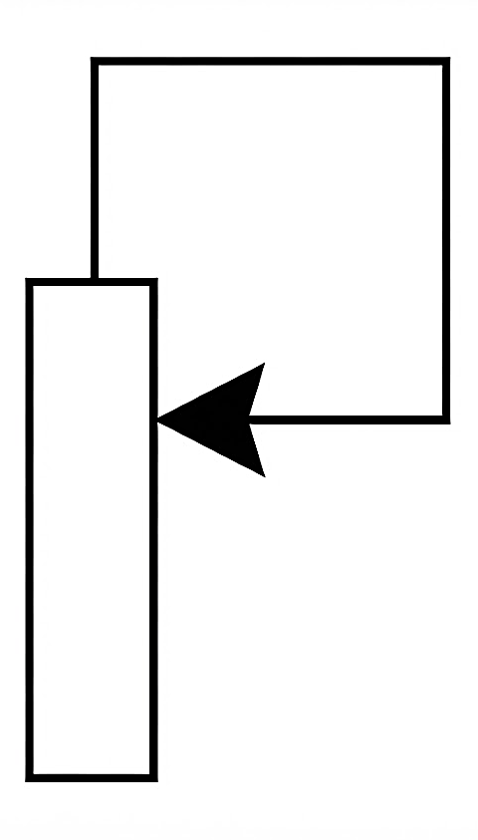
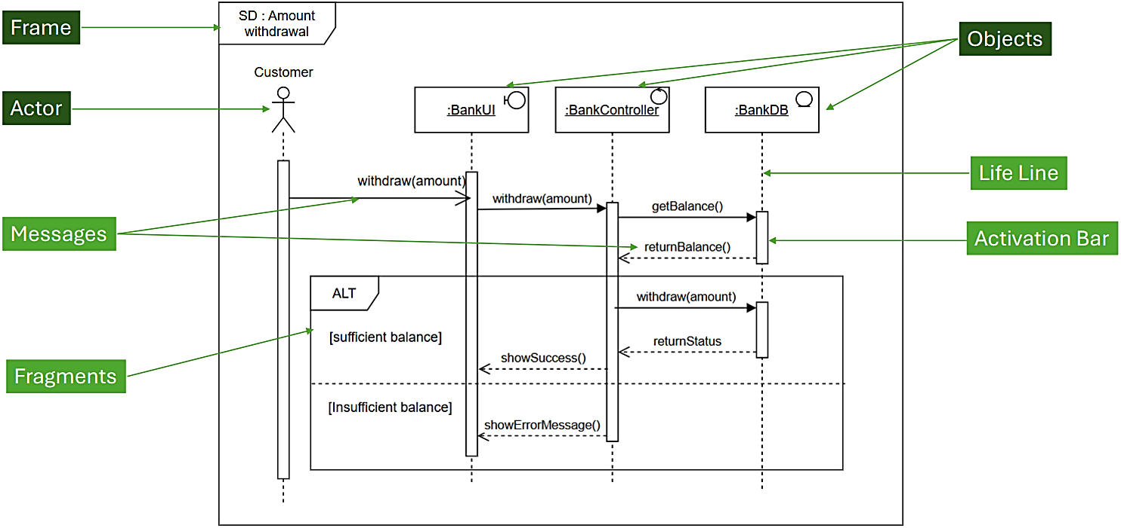
Agile Development: Set of methods & practices based on Values & Principles expressed in Agile Manifesto → 4 key Values (defines core philosophy of Agile) & 12 Principles (guides on how these values are applied in practice); Handles changing requirements more effectively; Traditional Development: Cost ↑; Changes are not acceptable; Can detect errors only in the latter part of the SDLC; Less/no iterations; Lack of transparency; Time consuming; Rework required; Customer may not get what they need; Requirements may change; How Agile Helps: Delivers software in small increments; Encourages regular customer feedback; Adapts to changing requirements; Identifies issues early; Focuses on delivering high-value features first; Helps teams deliver better software faster while responding to change; 4 Key Values: Individuals & Interactions; Working Software; Customer Collaboration; Responding to Change; Agile Methodologies: Provides overall structure for managing a project; Scrum: Work is organized into Sprints; Kanban: Work is managed using a visual board; Extreme Programming (XP): Focuses on engineering practices & code quality; Lean Software Development: Focuses on eliminating waste & maximizing value; Agile Practices: Specific techniques used by development team during implementation; Test-Driven Development (TDD): Write tests before writing code; Pair Programming: 2 developers work together on same task; Behavior-Driven Development (BDD): Defines system behavior using business-focused scenarios; Scrum: Divides work into short iterations → Sprints; Working software at the end of each Sprint; Feedback collected regularly; Helps teams work collaboratively & adapt to change; Consists of Roles, Artifacts & Activities; ¹Roles: Product Owner: Represents customers & stakeholders; Define & prioritize requirements; Maintain Product Backlog; Communicate customer needs to team; Decide what features should be developed; Accept/reject completed work; Maximizing value of product; Scrum Master: Ensures Scrum practices are followed & supports team; facilitator, not a traditional project manager; Remove obstacles that affect progress; Promote collaboration & communication; Helping the team work effectively; Developers: Build & deliver product; Design, develop & test software; Complete Sprint Backlog items; Collaborate w. other team members; Maintain product quality; Deliver a working product increment at the end of each Sprint; ²Artifacts: To provide transparency & help teams manage their work; Helps Scrum Team understand what needs to be done & how much progress has been made; ¹Product Backlog: Prioritized list of requirements, features & improvements for product; Work is prioritized; Items are placed in correct sequence; Highest-value items are completed first; Changes & evolves throughout project; Product Owner is responsible for creating & maintaining; ID (PBI-1…), User Story, Priority (High, Medium, Low); Ways to store: Collection of index cards/post-it on the wall; Excel; User Stories; User Stories: Concise description of a Functionality that will be valuable to users of system; Convenient format for expressing desired business value for many types of product backlog items; Understandable to both business & technical people; As a <user role> I want to <goal> so that <benefit>; Good User Story: Clearly identify user role; Avoid technical implementation details; Selection Criteria: Highest Business Value; Core System Functionality; Foundation for Future Features (other features should depend on this core function); Deliver a Working Product Early (users could be able to use basic system); Testable Acceptance Criterion: Makes its boundaries & expected behavior testable; Provides observable Given-When-Then acceptance criterion w/o prescribing implementation; ²Sprint Backlog (release backlog): List of user stories identified by Scrum team to be completed during sprint; Subset of product backlog; Work is performed in iterations/cycles of up to a calendar month → sprints; Before starting Sprint, team should come up w. Sprint backlog; A to-do item can belong to sprint backlog; Task ID (T-1.1…), Task, Est. Hours; ³Burn Down Charts: Graphical representation of work left to do (backlog) vs. time; Useful for predicting when all of the work will be completed; ³Activities: During each sprint, plan, monitor, review & improve their work; ¹Sprint Planning: Decide what work will be completed during Sprint; Conducted at beginning of each Sprint; Sprint ID (SP1-01…), User Story, Priority; Always develop highest-value features 1st & deliver working software in small, incremental releases; Purpose: Select Product Backlog items for Sprint; Define Sprint Goal; Create Sprint Backlog; ²Daily Scrum: Monitor progress & discuss obstacles; Short daily meeting (typically 15mins) held by Scrum Team to monitor progress; Key Questions: What did I complete since the last Daily Scrum? What will I work on next? Are there any obstacles blocking my progress? ³Sprint Review: Conducted at end of Sprint; Demonstrate completed work; Gather stakeholder feedback; Review progress toward Sprint Goal; Update Product Backlog if needed; Inspect product outcomes w. stakeholders; ⁴Sprint Retrospective: Reflect on team's performance; Reflect on Sprint; Identify what went well; Identify areas for improvement; Plan improvements for next Sprint;
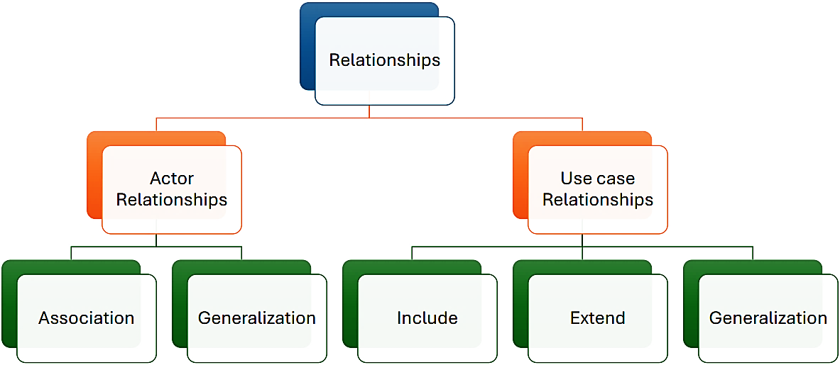
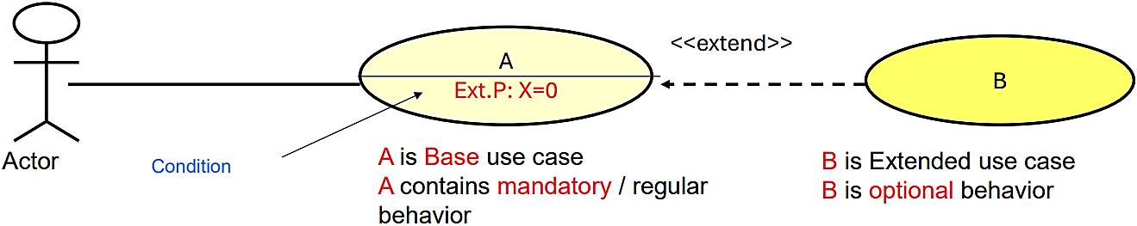
Requirement Specification: After document requirements are identified, we use graphical notations: Use Case Diagrams: Represents proposed functionality of new system; Captures functional requirements; Helps to demonstrate high-level behavior; Supports requirement specification; Act as means of communicating w. stakeholders about what the system is intended to do; Can be used to communicate to management, customers & other non-development people; It focuses on WHAT a system will do when it is completed (but not HOW a system will do anything); Components: System: Something that performs function(s); System Boundary: Boundary between system & actors; Actors: External entities; Roles (human users, external hardware, other systems) adopted by those participating; Have direct interactions; Use Cases: High level activities (primary tasks) to be supported by system; Unit of behavior; Verb-noun phrase (reserve a room); Relationships / Links: Generalization (Inheritance): Unfilled Arrow; Parent (characteristic & behavior) ← Child (can add, modify, or ignore any of the characteristics & behaviors); Include: Base use case explicitly incorporates behavior of another use case at a location specified in the base; Included use case never stands alone; It only occurs as a part of some larger base that includes it; Enables us to avoid describing the same flow of events several times by putting common behavior in a use case of its own; Arrow targets reused mandatory use case; Extend: Base use case implicitly incorporates behavior of another use case at certain points → Extension points; Base use case may stand alone, but under certain conditions, its behavior may be extended by behavior of another use case; Arrow targets complete base use case; Use Case Scenarios: Scenario: Formal description of the flow of events that occur during execution of a Use Case instance; Defines specific sequence of events between system & external Actors; Main scenario: Describes what happens when everything goes to plan; It’s written under assumption that everything is okay, no problems occur & it leads directly to desired outcome of the use-case; Other scenarios: Describes what happens when variations to Main scenario arise, often leading to different outcomes; Flow of events should include: How & when use case starts & ends; When use case interacts w. actors; What objects are exchanged; Basic flow & Alternative flows (exceptional) of behavior;
Activity Diagrams: Dependencies between activities; Represents Workflows; When to use? Modeling business processes; Analyzing system functionality to identify the use cases; Analyzing individual use cases in detail; Clarifying concurrency issues; Initial/Start Node: Filled Circle; Final Node: Within circle; Action Node: Rounded rectangle; Task which needs to be done (verb phrase in present tense); Sequence of actions; Transition (control flow/directed flow/edge): Arrow; Decision Node: Diamond; [Guard expression] for each possibility; No limit on the # of branches; Merge Node: Diamond; To merge the flow of control from branches back together; Call action/Sub Activity: Rake symbol within action node; An activity that is defined in more detail on another activity diagram; Forks & Joins: Thick Bar (starting & ending); Activities that can occur in parallel; Order of execution of the activities can be whatever is convenient for the implementation; Every fork must have a join; Thread: Flow of control; Iteration: Asterisk; Alt. we can use a decision node to represent an iteration; Guard conditions should be mentioned; Partitioning: An activity group for actions that have some common characteristic; It corresponds to organizational units/business actors in a business model; Swim lanes: Sub-partitioning (e.g. Order department is a subclass of Department class);
Behavioral Model: How systems behave in response to events; We model behavior of software using UML Interaction diagrams: Sequence Diagrams (time-ordered interactions); Communication Diagrams (Collaborative interactions); Why Interaction Diagram? Understand object collaborations; Provide time-sequenced view of interactions; Aid requirement validation & design refinement; Bridge use cases to design; Components: Participants: Actor: External human users/external HW/services who send/receive messages; Object: Instance of a class which interacts w. each other & actors: Named object (Object name : Class name); Anonymous object (: Class name); Stereo Types: Helps identify the responsibilities of participants; Boundary Objects: Objects in the boundary of the system which the actors act upon; :BankUI; Controller Objects: Objects which control & coordinate other objects; :BankController; Entity Objects: Objects which represent information & behavior in the application domain; :Order; Lifelines: Each participant has corresponding lifeline; Activation Bar: Shows period during which a participant is executing an operation/controlling an activity; Messages: Communication between different active objects/participants; Asynchronous messages: Sender doesn’t wait for the receiver to finish processing the message (for any return values), it continues immediately; Unfilled arrow; Synchronous messages: When sender waits until receiver has finished processing message; Filled arrow; Return messages: return value (balance, success, error); Dotted unfilled arrow; Self message: When one method calling another method belonging to same object (message to same lifeline); Interaction Fragments (TAGS): Reference Fragment (REF Tag): Reference to another interaction diagram; Helps manage large diagram by splitting & potentially reusing, a collection of interactions; Alternative Fragment (ALT Tag): Fragment w. ≥ 2 alternatives to execute w. guard conditions; Operand whose guard condition is true is executed; An ‘else’ operand may be included as the default flow; Optional Fragment (OPT Tag): Handles a single condition situation; If guard condition fails, behavior is simply skipped; Loop Fragment (LOOP Tag): Messages are repeated while its guard condition remains true; Stops when it’s false; Minimum & maximum iteration limits may also be specified; Parallel Fragment (Par): When processing time required to complete portions of a complex task is longer than desired, some systems handle parts of the processing in parallel; Parallel execution of behaviors; Different operands can be interleaved in any way as long as the ordering imposed by each operand is preserved;
State Machine Diagram: Models the behavior of a single object, specifying the sequence of events that an object goes through during its lifetime; Only one state machine diagram for a class; Typically drawn only for classes which contains significant dynamic behavior; ¹States: Condition that someone/something (object) is in at that particular time; Shown as rectangle w. rounded corners, w. state name shown within state; While in the state, object satisfies some condition, performs some action, or waits for some event; Special States: Initial state: Object being constructed; Filled black circle; Final State: Object being destructed; Circle w. a dot inside; Types: ¹Simple State: Doesn’t have sub states/compartments; Simple rounded rectangle & state name inside; ²Simple State w. Compartments: Maybe subdivided into multiple compartments separated from each other by a horizontal line (Name compartment; Internal behaviors compartment); ¹Name compartment: Holds the name of the state as string; ²Internal behaviors/activities compartment: Holds a list of internal behaviors associated w. a state; <<behavior-type-label>>/<<action>>; <behavior-type-label> identifies the situation under which will be invoked & can be 1 of the following: Entry: Identifies a behavior, specified by corresponding expression, which is performed upon entry to the state; Exit: “” exit from the state; Do: Performed within a stage; Ongoing work that an object performs while in a particular state; Started after entry action is finished; Work automatically terminates when the state is exited; Maybe interrupted; Can’t change the state of object (unlike actions Entry & Exit), so interrupting them won’t corrupt the state of the object; ³Composite State: Has sub states (nested states); Sub states are in a separate compartment – Decomposition; Hidden Decomposition Indicator: In some cases, it’s convenient to hide the decomposition of a composite state; E.g.: There maybe large number of states nested inside a composite state & they may simply not fit in the graphical space available for diagram; Composite icon: 2 small connected circles by a line; Usually in the lower right-hand corner; ²Transitions: Transitions from 1 state to the next; Lines w. open arrow heads; Elements: Source state: State of the object before transition; Target state: “” after transition; Trigger: Event that causes the transition; Self-Transitions: Starts & ends in the same state; State in question is exited & entered again; Commonly used to restart the current state, causing exit actions to happen, followed by entry actions; Types of Triggers: Call Event: message(parameters); Denoted by the name of the triggering operation; Used to represent a transition that occurs as a result of a message being received by the object; Arguments are optional; E.g.: buttonPressed(buttonID); Change Event: when(condition); Occurs when a condition/boolean expression becomes true; Strictly, condition should be a Boolean expression, but some engineers use plain English; E.g.: when(T>100°) or when(temperature exceeds 100°); Time Event: after(time period); Period can be expressed in any stated units; E.g.: after(1 minute); Triggers w. Guard Conditions: All triggers can have guard conditions, but these are optional; message() [Guard Condition]; State Machine Diagram Guidelines: Keep the diagram simple: If it’s too complex, perhaps it should be broken down into separate diagrams; Question “Black-Hole” States: Black-hole state: Has transitions into it but none out of it, something that should be true only of final states; Question “Miracle” States: Miracle state: Has transitions out of it but none into it, something that should be true only of start points;
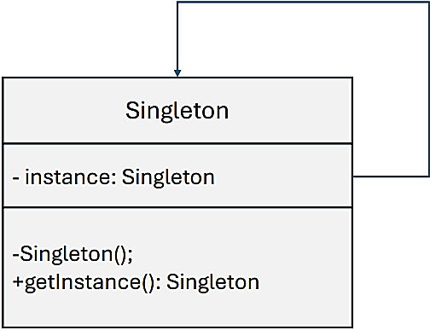
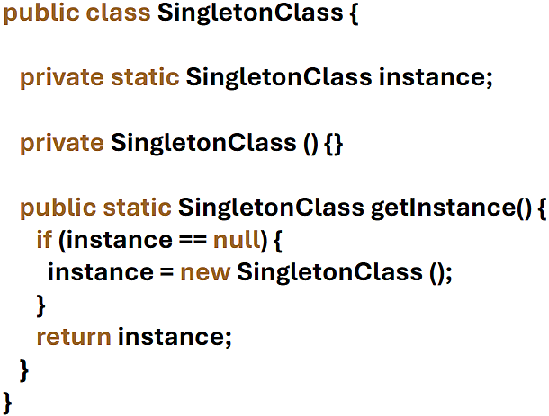
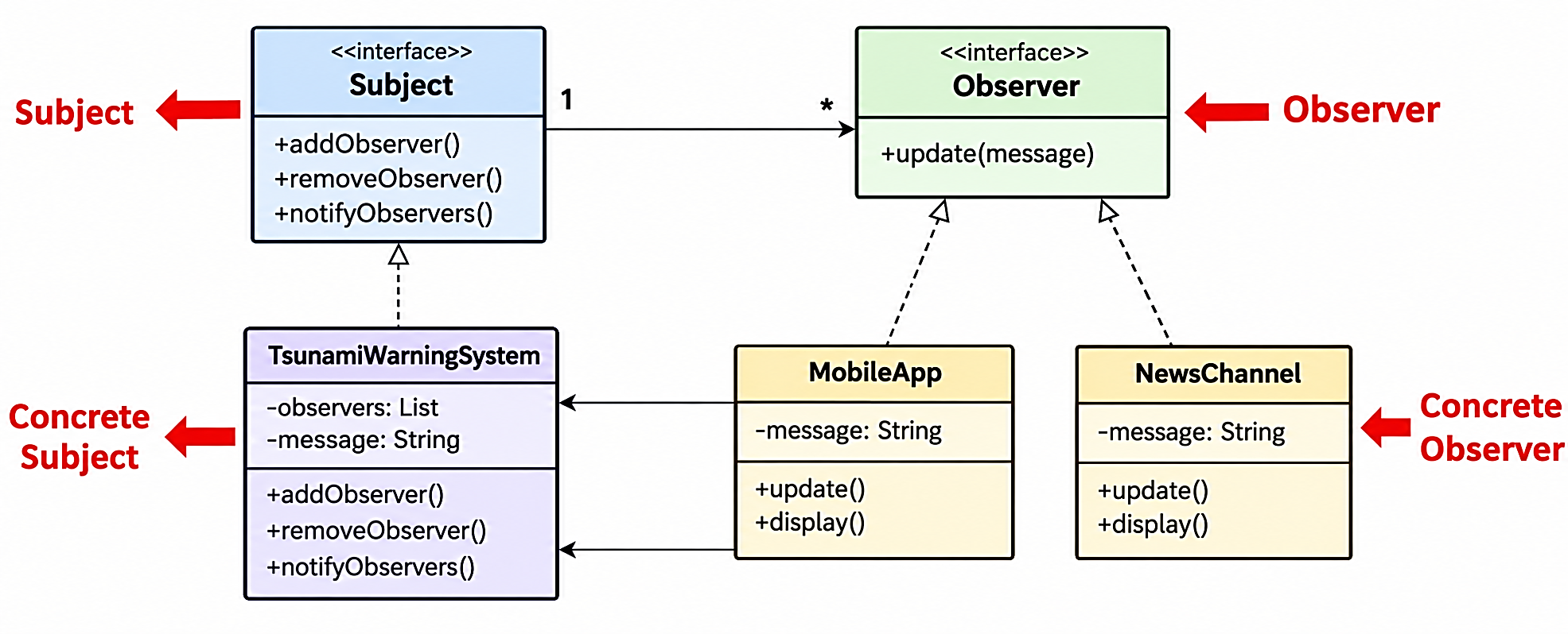
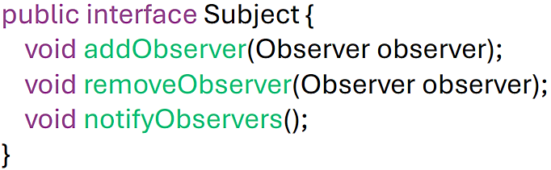
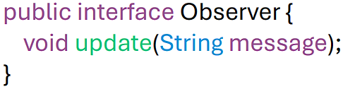
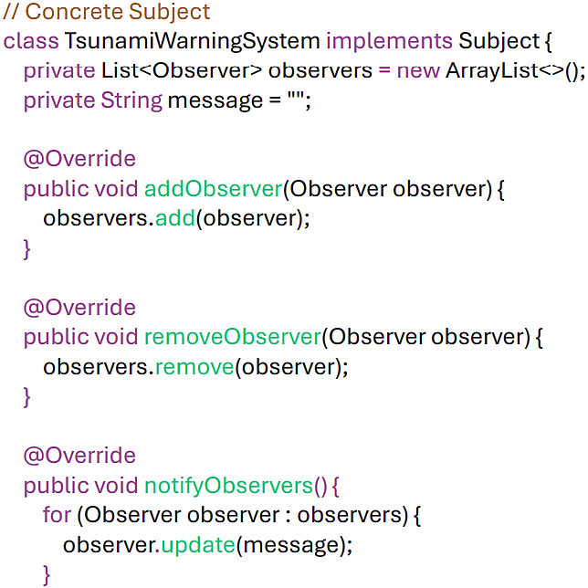
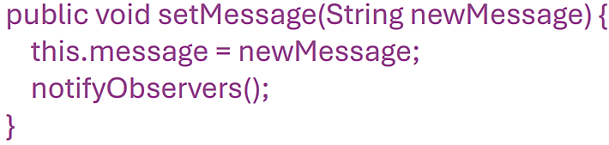
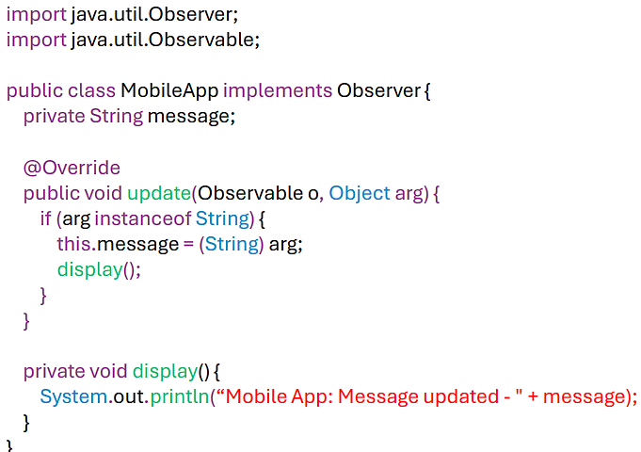
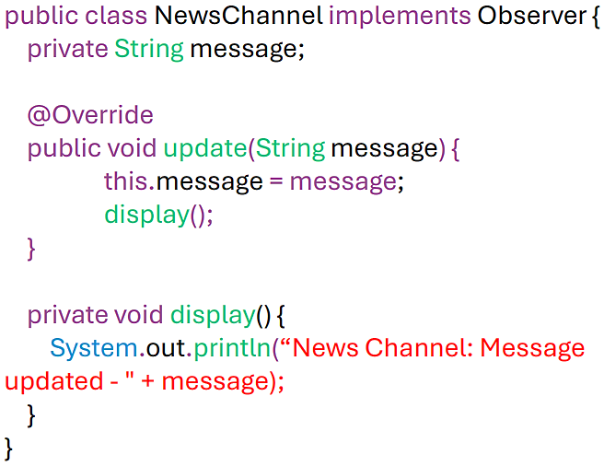
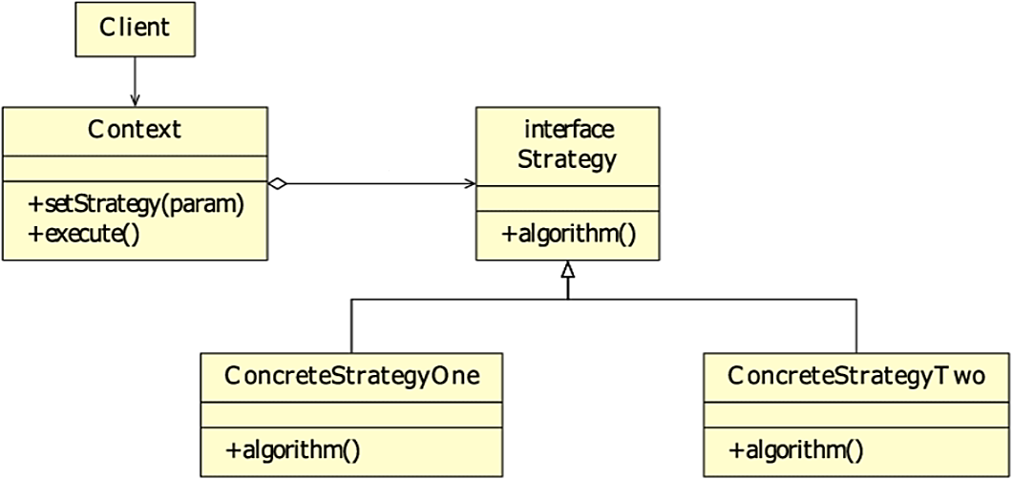
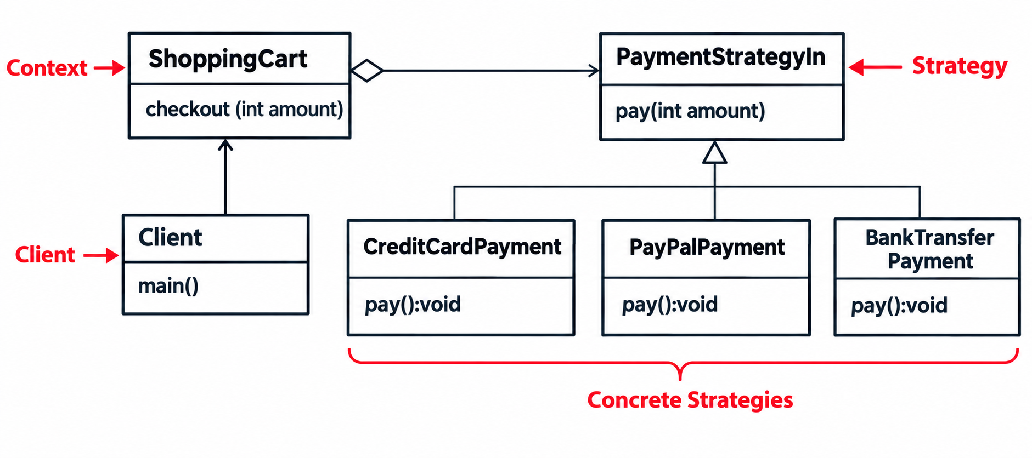
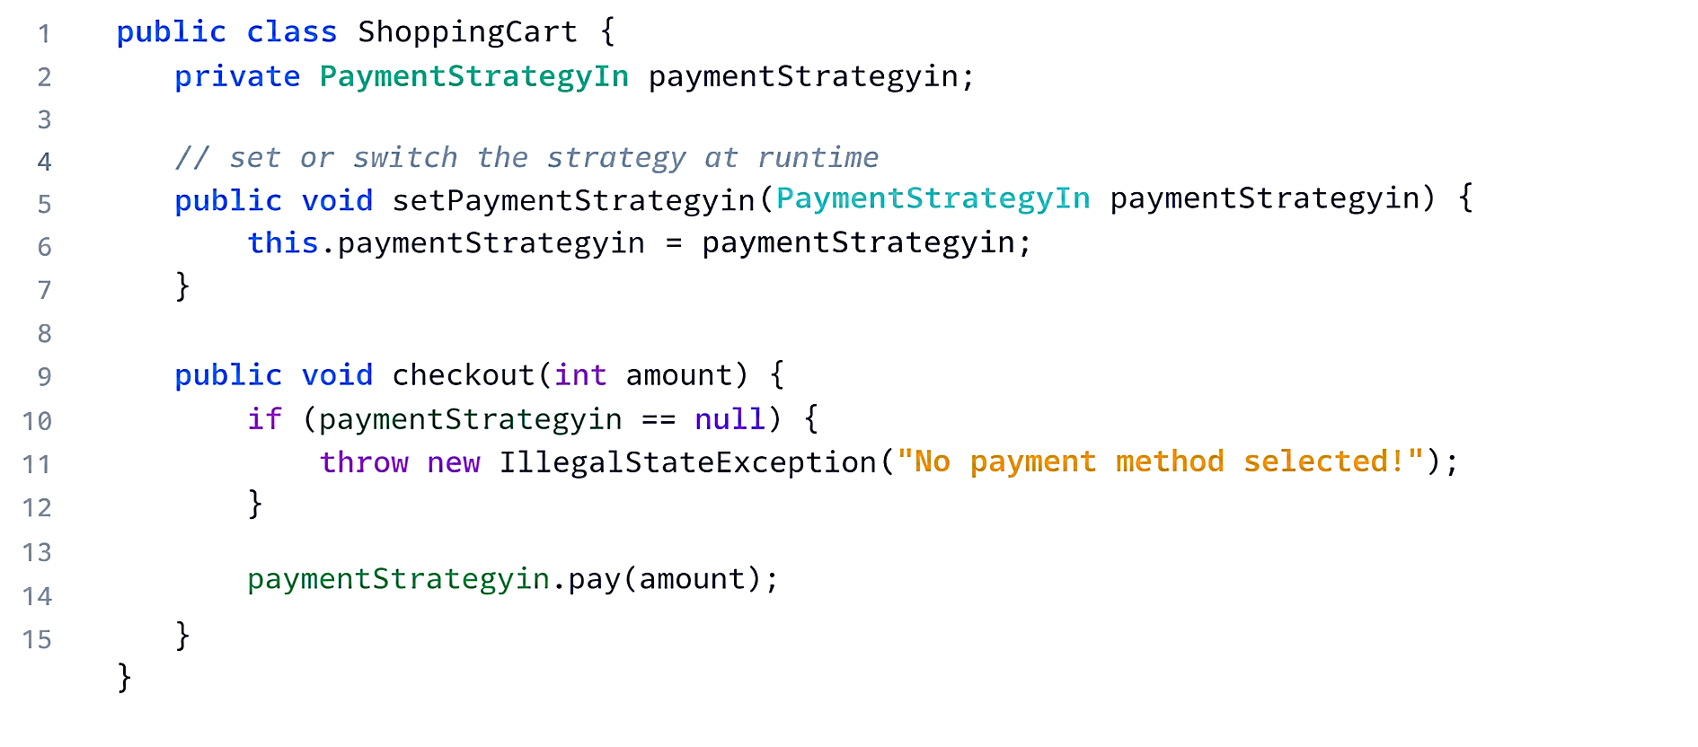
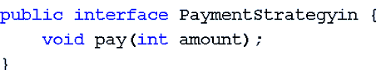
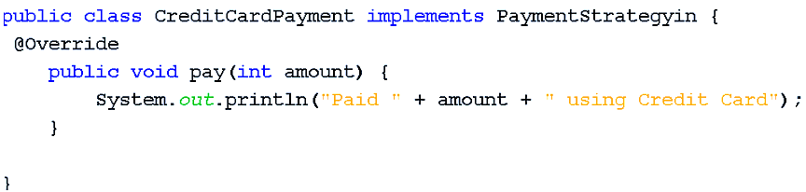
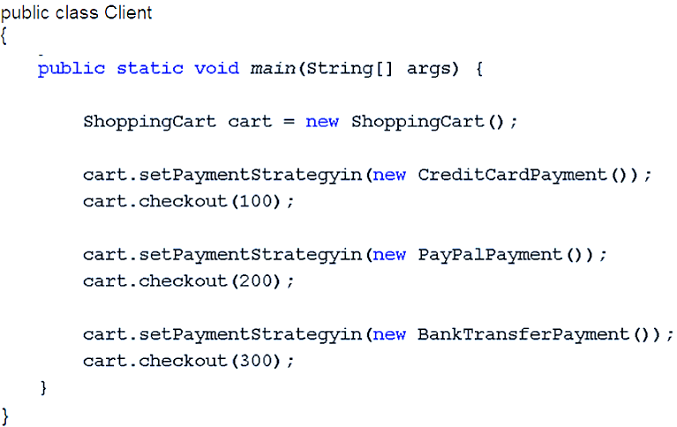
Design Pattern: Proven solution to a common software design problem in a specific context (problem that someone has already solved); Provides a reusable template for solving recurring design issues (model/design to use as a guide); Helps developers communicate ideas clearly using a shared vocabulary; Inspired by Christopher Alexander (architect, 1977), and formalized in software by the Gang of Four (1994); Each pattern describes a problem which occurs over and over again in our environment, and then describes the core of the solution to that problem, in such a way that you can use this solution a million times over, without ever doing it the same way twice; Helps you think about how to solve a software problem; Reusable: Design patterns are adaptable & not limited to a single problem; Prevent the Need for Refactoring Code (optimal solution); Each pattern enables system changes w/o full redesign & often uses less code; Key Components: Name: Describes the pattern; Adds to common terminology for facilitating communication; Problem: Describes when to apply pattern; What is the pattern trying to solve? Solution: Describes elements, relationships, responsibilities & collaborations that make up the design; Consequences: Results of applying pattern; Benefits & Costs; Subjective, depending on concrete scenarios; ¹Creational: Deals w. object creation & initialization, providing guidance about which objects are created for a given situation; E.g.: Factory method; Builder; Abstract factory; Singleton; Singleton: How can we ensure that a class creates only 1 object & prevents other classes from creating additional objects? Define a private constructor, store the single instance in a static variable & provide a static method that returns the instance; Ensures that a class has only 1 instance & provides a global access point to that instance; It’s useful when the entire application must share 1 object; Singleton class declares the static method getInstance that returns the same instance of its own class; Private static instance variable of the same class that is the only instance of the class; Static – variable belongs to the class (only 1 copy of the variable exists); Initially its value is null; Private constructor prevents other classes from directly creating Singleton objects using new Singleton(); If the class has > 1 constructor, mark each one as private; getInstance() method provides access to the single object; Declare a static method w. the return type as an object of this singleton class; No matter how many times u call it, u always get the same instance; Advantages: Resource Effectiveness (saves resources by reusing the same instance); Global Access of the Instance (provides a global point of access to the instance); Thread Safety (can be implemented to ensure safe concurrent access); Disadvantages: Difficulty in Testing (singleton classes can be difficult to test because they keep shared global state; A change made during one test may affect another test); Possibility of Tight Coupling (classes may directly depend on the Singleton object, making them harder to change, reuse or test independently); Potential for Excessive use (can lead to poor design & maintainability issues); ²Structural: Deals w. class & object composition, or how to assemble objects & classes into larger structures; Relationship between entities; E.g.: Adapter; Decorator; Façade; Proxy; ³Behavioral: Deals w. communication between objects & how responsibilities are assigned between objects; E.g.: Observer; Strategy; Command; State; Chain of responsibility; Visitor; Observer: One-to-many dependency between objects so that when 1 object changes state, all of its dependents are notified & updated automatically; E.g.: Social media (when a person updates their status, all their followers get a notification); Components: Subject: Maintains a list of observers; Provides methods to add/remove them & notifies them of state changes; Outlines operations a subject should support; Observer: Defines an interface w. update() method to ensure all observers receive updates consistently; Concrete Subject: Specific subject that holds actual data; On state change, it notifies registered observers; Concrete Observer: Implements observer interface & reacts to subject updates; Pros: Allows information/data transfer to multiple objects w/o any change in observer/subject classes; Adheres to loose coupling concept among objects that communicate w. each other; Cons: Subscribers/observers are updated in a random sequence; Can increase complexity & potentially cause efficiency issues if it’s not executed properly; Strategy: Defines a family of algorithms, encapsulates each one & makes them interchangeable; Allows algorithms to vary independently from the clients that use them; Key Concepts: Defines a Family of Algorithms (bubble, quick, merge sort); Different ways to solve the same type of problem; Encapsulates Each One (each algorithm implemented in its own class); Wrapping each algorithms inside its own class so it’s separated from others (instead of writing big if-else code, each sorting method is written in its own class); Makes them interchangeable (all follow common interface, so they can be swapped at runtime w/o changing the main code); Let’s algorithm vary independently from clients that use it; Traditional Approach: All logics are implemented into 1 big method w. several if-else/switch statements; Logic tied up in long if-else chains; Hard to extend, tightly coupled, & violates good OOP principles; Components: Context: Main class that client interacts w.; It doesn’t implement the algorithm itself but keeps a reference to a strategy object & uses it; Strategy: Common interface that all strategies must follow; Defines a method but doesn’t provide implementation; Concrete Strategies: Real classes that implement the Strategy interface; Client: End-user code/ application logic that selects which strategy should be applied; Practical Uses: Use when there are multiple interchangeable ways to achieve the same goal & want to switch easily @ runtime; E.g.: Payment Systems (credit card, PayPal, bank transfer); Sorting Algorithms (quicksort, merge sort, bubble sort); Compression tools (zip, rar, gzip); Navigation apps (fastest route, shortest distance, avoid tolls); Authentication (user/password, OAuth, biometric); Game AI (aggressive, defensive, stealth attack); Advantages: Eliminates long if-else/switch statements (each algorithms lives in its own class, so code is cleaner); Easy to Extend (add a new algorithm by creating a new class, no need to change old code); Runtime Flexibility (change behavior – algorithm/strategy – while the program is running); Follows OOP Principles (open/closed principle – add new code w/o modifying old code; single responsibility principle – separates business logic from algorithms); Improves Reusability (can be reused in other projects w/o depending on the context); Disadvantages: More Classes to Manage (each new algorithm = a new class → can increase project size); Client Awareness Needed (programmer/system must know which strategy to pick & when); Slightly More Complex Design (compared to simple if-else, setting up interfaces & classes takes effort) Overhead for Small Problems (if only 1 or 2 algorithms exist & they rarely change, Strategy may feel like over-engineering);

